TC-CMS-037
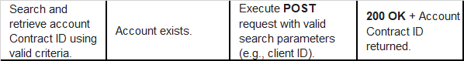
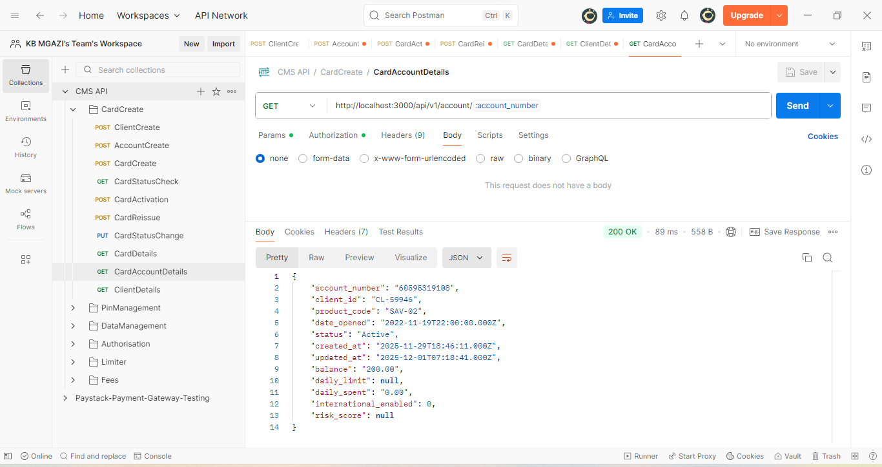
Response:
{
"account_number": "60595319108",
"client_id": "CL-59946",
"product_code": "SAV-02",
"date_opened": "2022-11-19T22:00:00.000Z",
"status": "Active",
"created_at": "2025-11-29T18:46:11.000Z",
"updated_at": "2025-12-01T07:18:41.000Z",
"balance": "200.00",
"daily_limit": null,
"daily_spent": "0.00",
"international_enabled": 0,
"risk_score": null
}

